Task 13

1. Chat GPT

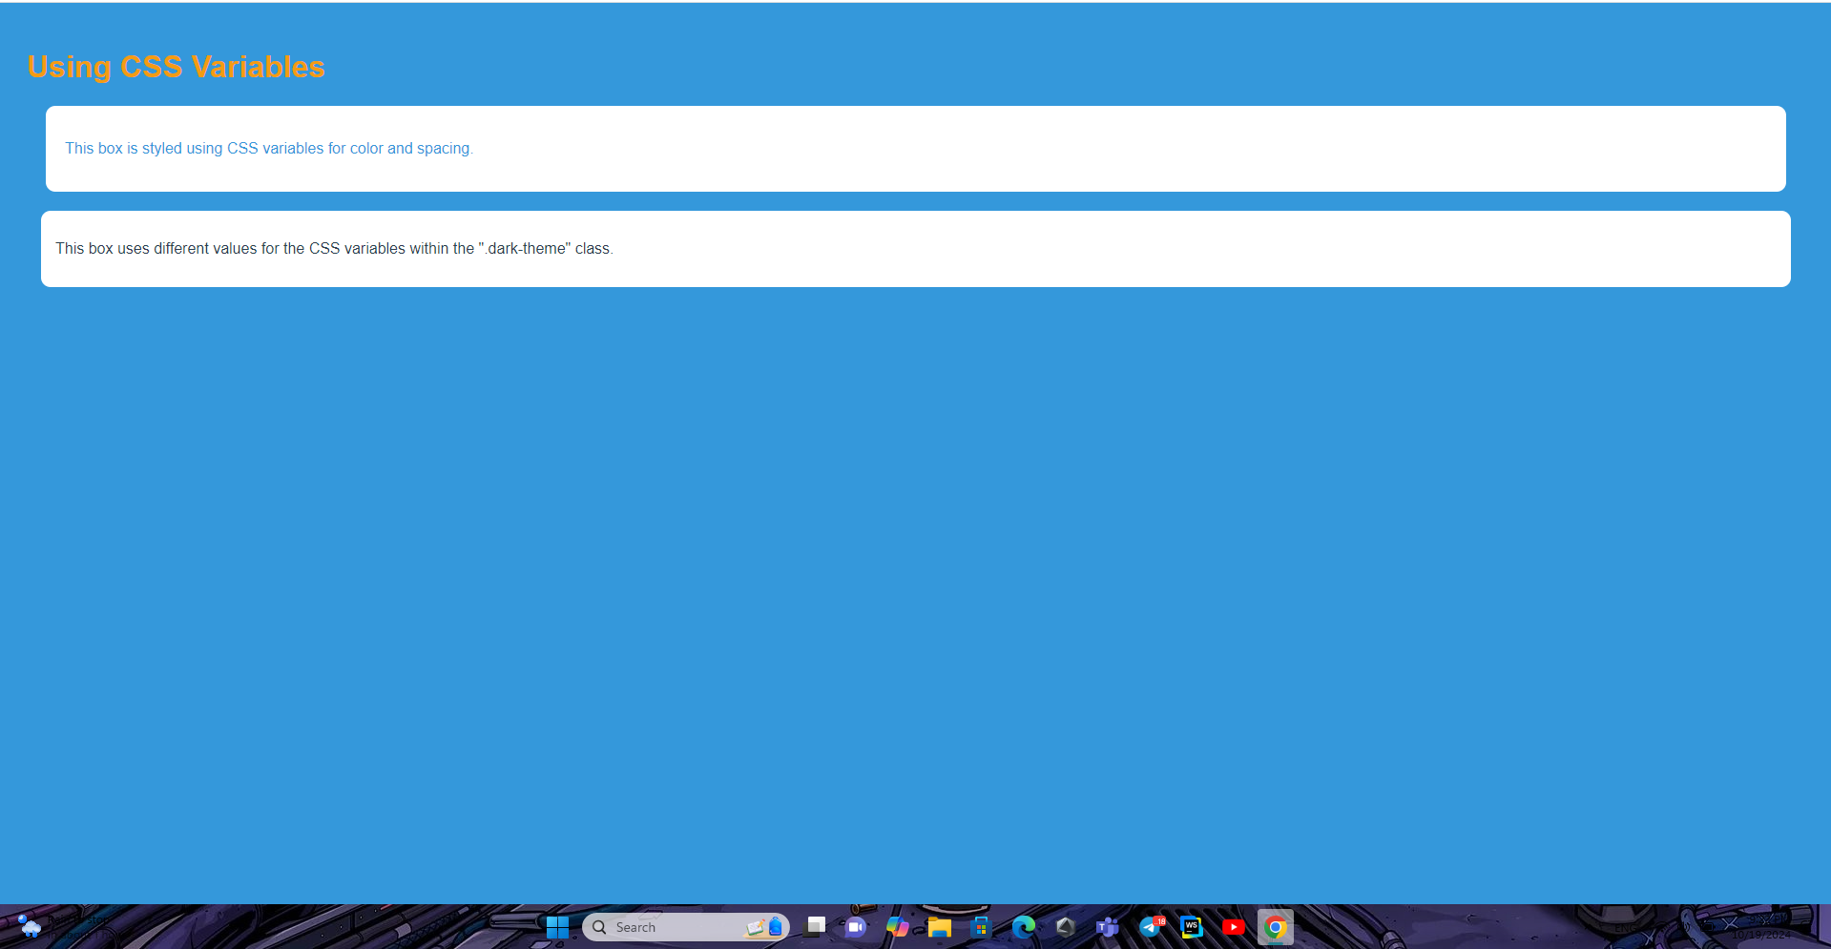

2. Gemini



Both follow the prompt. But Chat GPT is lock better and explaining is good.